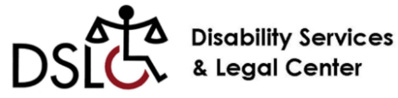****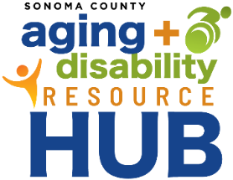

No Wrong Door Standing Committee

Tuesday, October 22nd 10:30am-11:30 AM

Adult and Aging, 3725 Westwind Blvd, Santa Rosa

Carnelian Room

10:30 am **Welcome and Introductions (Betsey)**

* + - Check in

10:40 am **Brief overview of Brown Act/meeting guidelines (Sara)**

10:45 am **History/Overview of ADRC/ADRH (Betsey)**

**The Aging and Disability Resource Connection (ADRC**) initiative began as a collaborative effort between the State of California, the federal Administration for Community Living (ACL), the Centers for Medicare & Medicaid Sevices (CMS), and the Veterans Administration (VA). The ADRC’s purpose is to provide a **single coordinated system** for people seeking reliable information and access to **Long-Term Services and Supports (LTSS)**.

ADRCs are intended to act as a “[No Wrong Door](https://acl.gov/programs/connecting-people-services/aging-and-disability-resource-centers-programno-wrong-door)” system, enabling people of all ages, incomes, and disabilities to connect with any one ADRC partner organization for access to a full array of Long-Term Services and Support (LTSS) options in the community.

California ADRCs are led by a core partnership between [Independent Living Centers](https://www.dor.ca.gov/Content/DorIncludes/documents/IndependentLiving/ILC%20Directory%20FY18-19%20V.11.18.docx)(ILCs) and [Area Agencies on Aging](https://www.aging.ca.gov/Providers_and_Partners/Area_Agencies_on_Aging/) (AAAs), and include a wide array of extended partner organizations.

* Short overview of ADRC and ADRH development
* Four core services and Referral Process
* Role of ADRC Advisory Committee (past)
* Vision for NWD Committee
* Q & A

11:05 am **Committee structure (Jenny)**

* Confirm regular meeting schedule
* Confirming members
* Elect committee chair and Vice Chair
  + Describe roles and responsibilities

11:25 am **Public comment**

11:30 pm **Wrap up**

**Sonoma County Aging and Disability Commission**

**No Wrong Door Standing Committee**

Purpose:

The No Wrong Door Standing Committee supports the continued efforts in the Sonoma County community to increase equitable access to information, assistance, and supports needed for older adults and people with disabilities to live as independently as possible at home.

The Standing Committee supports these efforts through:

* Providing feedback, guidance and planning support related to No Wrong Door activities and initiatives
* Identifying unmet needs within the community and developing strategies to address them
  + Ensuring input from consumers, service providers and community members
  + Ensuring that all target populations are adequately served
* Serving in an advisory capacity for the Sonoma County Aging and Disability Resource Hub (ADRH)
* Advocacy and community engagement

Anticipated typical activities:

* Routine meeting attendance (Aging and Disability Commission meetings and Standing Committee meetings)
* Review staff provided materials or plans and provide feedback and guidance. Examples include: marketing material/information or community engagement strategies.
* Advocacy on behalf of our target populations and overall Sonoma County community at Commission level, committee level, and possibly community or legislative levels.
* Participation in community engagement activities. Examples include:
  + networking at community events that support services for older adults and people with disabilities,
  + engaging potential community partners
  + providing education/overview of services provided by Area Agency on Aging, the Aging and Disability Commission, or the Aging and Disability Resource Hub
  + support activities that assist in identifying and addressing barriers to accessing services

Structure

* The committee must include broad representation with a minimum 20 percent share of individuals who are consumers of LTSS or caregivers of those who use LTSS. (per [ADRC designation criteria](https://aging.ca.gov/download.ashx?lE0rcNUV0zZnb2y%2bi4EbJw%3d%3d) set by CDA)